General Goals and Objectives

The goal of 8th grade science is to review the important information you have learned in your middle school career while expanding your knowledge in certain areas so that you can be a scientifically literate member of society, pass the 8th grade Science STAAR, and be prepared for the Science classes in high school.


Academic Honesty

It is expected that ALL work completed in this class is a product of your own mind and effort – NOT AI. If you give another student answers to a question or take answers from a parent or another student or use AI to help you, it is cheating. Cheating will result in an automatic zero that may NOT be made up. These consequences apply to ALL students (both those giving the answers, and those writing them down).

A zero obtained because of cheating may NOT be made up. Any other failing class assignments can be corrected to a maximum of 70 during tutorials (excluding tests as they are curved).
Make Up Work
I will place any handouts in our class folder or on Google Classroom when you are absent. Upon return, you should glue the pages in and complete the missing assignments using your partner’s data from any lab or you may see me during tutorials or complete the work at home on Google Classroom. You have one day for excused absence to complete work.

Need Help?
If you are struggling or have questions about assignments, either raise your hand, send me a note through Google Classroom, or see me during tutorials for extra help. I will do my best to help you understand.

Conclusion
I want you to be successful in science. I encourage you to participate in class and ask questions when you do not understand. I am looking forward to a very exciting and productive year!

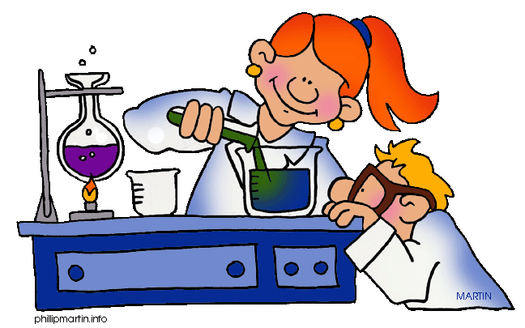

Brochure text based on Dr. Bailer’s Science Lessons used with permission. Clip art by Phillip Martin. Visit his site for more wonderful images.

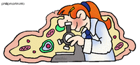

Welcome to
Eighth Grade Science
At
Bland Middle School

Teacher: Mrs. J. Rhea
E-mail: julie.rhea@blandisd.org
School phone: 903-776-2239

I hope you have had a safe and relaxing summer. The following information will help you to succeed in science this year.

Eighth grade science is an integrated science course focusing on the following:

1st 9 weeks – Safety, Properties of Matter,
Chemistry, Force and Motion,
and Energy transfer in Waves

2nd 9 weeks – Investigating waves (cont.),
Plate Tectonics, Our Universe,
Tides and Seasons

3rd 9 weeks – Weather, Climate and Earth’s
Ecosystems

4th 9 weeks – Ecosystems, Cell Structure and
Function, Traits of Organisms,
and Student Projects

Philosophy

Science is more than just a class; it is a way of knowing, thinking and using that knowledge to explain the world around us. Some of you may think that you don’t like science, or that it is too hard for you. Others already know that science is one of their favorite classes. I believe that everyone learns by doing. The lessons and activities in my classroom are created to provide you with multiple opportunities for learning in a hands-on, minds-on design.

We will use a combination of the district curriculum and our interactive notebooks. You can keep up with class assignments through Google Classroom. Just be sure you log in using your student ID.


Materials

During the first week of school you are expected to bring the following items:
2 composition books (1 now, 1 later)
4 small glue sticks or tape (optional)
1 pen or pencil to use during class
- You may also need colored pencils occasionally.

Conference Time
My conference time is 2:30-3:20 pm. Parents, please make any appointments through the school office or through my email address.

Classroom Expectations

You will not do anything that will get in the way of your own learning or the learning of others. You are expected to participate in labs, activities and projects as well as follow ALL safety rules during labs wearing proper protective equipment.

Our Classroom Rules

1. Be in your seat with all materials working when the tardy bell rings.
2. Follow directions and read lab instructions CAREFULLY prior to each activity. (No food or gum in the lab.) Lab rules ALWAYS apply!!
3. Do nothing to disturb the learning process.
4. Respect others and yourself and treat each other well. (Keep your hands and feet to yourself.)
5. Clean your desk and materials after use.

Grading System

50% Daily work – classwork
50% Major grades – tests/projects
1 day late = 70, 2 days late = 50,
3 days late = 0. Those add up quickly so please turn things in on time! If you get a failing grade on exit tickets, you can and should redo them to bring your grade to a maximum of 70.
Remember, your grade is in your hands!

Projects

You can expect to complete one major project per semester. Most projects are to be completed at home, but occasionally some class time may also be given.
Class Routine
- Enter the classroom on time, you’re your supplies and ready to learn.
- If you are using a pencil, be sure it is sharpened at this time and prepare your journal for each day’s work. Get papers glued or taped in quickly and read carefully.
- Class time will consist of independent and group activities, hands on labs, vocabulary work and review.
- You are expected to be respectful, responsible and cooperative in the classroom at all times to all.
- You may NOT bring in backpacks, purses or big binders as they are a lab hazard. Your journals may either stay in the room or in your locker, but you need it EVERY DAY. Everything else (except your planner) stays in your locker! This includes phones. I will give you ample time to get ready before the bell, so there will be no need to interrupt the lesson. We also need to clean everything up before we leave the room.


Homework

We rarely have homework; but you will have daily assignments and sometimes projects. Not completing assignments will result in a zero until it is completed. Remember, 1 day late is a maximum 70 and 3 days late is an automatic zero. Let’s avoid those.

